Another technique involves an aggregation followed by a frequency count. There is a table called orders, which has a date, customer identifier, order identifier, and an amount. ***Write an SQL query that returns the distribution of orders per customer***

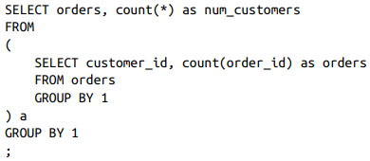

This can’t be solved with a simple query; it requires an intermediate aggregation step, which can be accomplished with a subquery.

1. Count the number of orders placed by each customer_id in the subquery.
2. The outer query uses the number of orders as a category and counts the number of customers

Another Example. **Write an SQL query that returns the distribution of sector per company**

